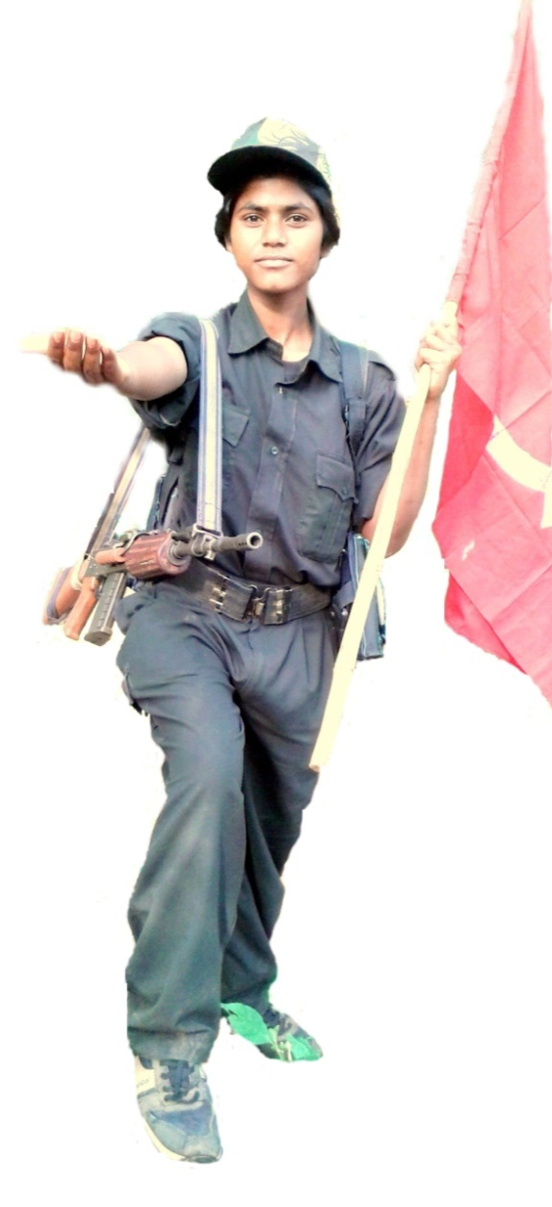
Celebrate the 14th Anniversary of PLGA

With Revolutionary Sprit

The fake development speeches

And commitment of Narendar Modi

NO SOLUTION of HUNGARS

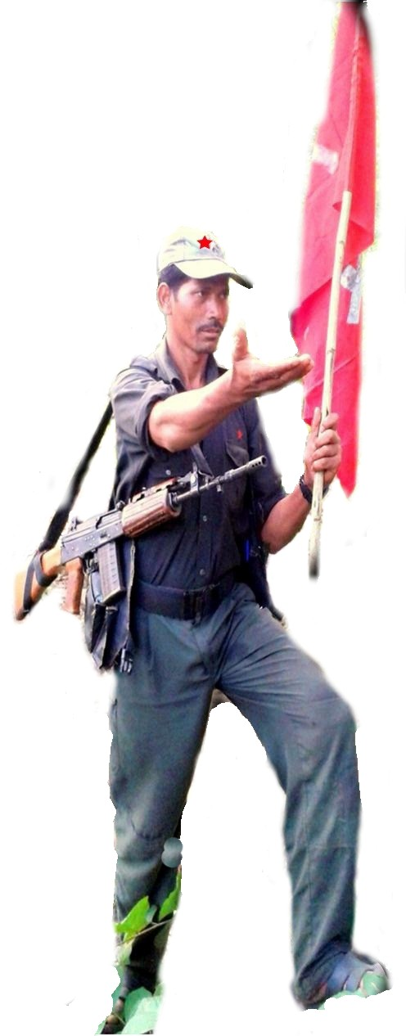
Join the Peoples Libration Gurilla Army
For Freedom of our nation
From MNCs, CBB and Landlords
Unite fight back and Defeat WAR ON PEOPLE 'OGH 3rd phase of the fascist Narendar Modi government.
Long Live CPI (Maoist)
Odisha State Committee- CPI (Maoist)

