China's Government Censors Shut Down References to Mao-Inspired Labor Movement
2018-08-21

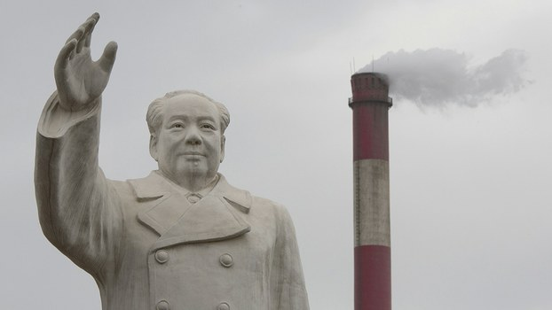
An enormous statue of Mao Zedong looms over the No. 1 Tractor Factory in Luoyang, in central China's Henan province, May 2, 2016.

Authorities in the southern Chinese province of Guangdong are swooping on what remains of a workers' movement at a technology factory aided by leftist followers of late supreme leader Mao Zedong.
Protesters who campaigned for an independent labor union at the Jasic Technology factory in Guangdong's Shenzhen city, said social media accounts and chat groups used to organize the protests are now being shut down by government censors.
"A lot of accounts and chat groups are being shut down if they openly discuss the story," a source close to the workers told RFA on Tuesday. "Using words such as Jasic, Shen Mengyu [and] Pingshan are all banned."
Earlier this month, Shen Mengyu, a Maoist labor activist and former Jasic employee, was taken away by unidentified personnel after she led the campaign for a union to negotiate collectively on behalf of some 1,000 Jasic workers that led to the detention of dozens of workers in the local Pingshan district police station.
"A lot of groups or individual accounts, including my own, have been shut down for using these words carelessly," the source said.
Shen was grabbed and forcibly restrained by three unidentified individuals in Shenzhen as she ate dinner with her father on Aug. 11, before being bundled into an unmarked vehicle, sources close to the campaign told RFA at the time.
The source said the movement had failed to achieve its goal, and had become politicized by the intervention of the Maoists, some of whom sought work at the factory in order to help organize the workers.
"The only people still involved with it now are the Maoist left ... the sort of young students who believe in what they read on the Utopia website," the source said. "That is to say, it's not really a labor movement any more; it has already become a form of political protest."
"To put it another way, it is a political and ideological standoff between the Maoists and the government."
The administration of President Xi Jinping has shut down a number of Maoist websites in recent years, including Utopia, but has generally allowed them to re-open after politically sensitive events, such as the trial of leftist icon and former Chongqing party chief Bo Xilai in 2013.
The Jasic protests have also inspired solidarity among labor groups across the internal immigration border in the former British colony of Hong Kong, however.
Around a dozen trade unionists waved placards and chanted slogans outside Beijing's Central Liaison Office in the city, hitting out at Shen Mengyu's sudden "disappearance."
They told reporters that local police had dragged their feet on investigating her whereabouts, and that surveillance cameras near where she was taken were "damaged," and that footage couldn't be recovered from them.
They called on the ruling Chinese Communist Party to order the Pingshan authorities to release those workers and supporters who remain in police custody following the protests.
The detention of workers came on July 27 as they protested the dismissal by factory management of those involved in a bid to set up a union through legal channels.
Seven workers said they had been beaten up by police for their involvement in the campaign to found a union, which began on July 18.
Collective action
Collective action by workers are common and widespread in China, as workers seek to use collective bargaining as a tool to defend their legal rights, according to a recent annual report by the Hong Kong-based China Labour Bulletin (CLB).
"The workers’ movement entered a new phase of more organized and purposeful collective action in which workers utilized the latest internet and telecommunications technology to more effectively pursue their objectives," the report said.
However, it hit out at "reforms" carried out in recent years by the government-backed All-China Federation of Trade Unions (ACFTU).
"The ACFTU can no longer merely indulge in superficial structural reforms which in reality do more to protect its own vast self-interests than China’s workers," CLB said in a summary of the report's findings.
"It is now absolutely essential that trade union reforms allow workers to reclaim ownership of the union and for the union to represent workers (not itself) in collective bargaining with employers at the enterprise level," it said.
"The union needs to be led and driven by those who believe in the core values of socialism—equality, justice and democracy," CLB said.
More than 40 years after his death at the age of 82, late supreme leader Mao Zedong still presents a political dilemma to the ruling Chinese Communist Party.
While revering Mao as the leader who founded the People's Republic on Oct. 1, 1949, the party has been forced to conclude publicly that the leader made some "serious political mistakes."
Locally funded statues of Mao have been torn down in recent years, reflecting official concerns over the potential use of the Great Helmsman's image as a focus for millions of poor and dispossessed people in China, including the country's army of petitioners, many of whom have lost their land or homes to government-backed development.
Reported by Yang Fan for RFA's Mandarin Service, and by the Cantonese Service. Translated and edited by Luisetta Mudie.

From the anti-communist Radio Free Asia website. Accessed Aug. 22, 2018.
https://www.rfa.org/english/news/china/movement-08212018103956.html

